A000-Eur-Italt-San Giorgio-Acheulian-1 mya

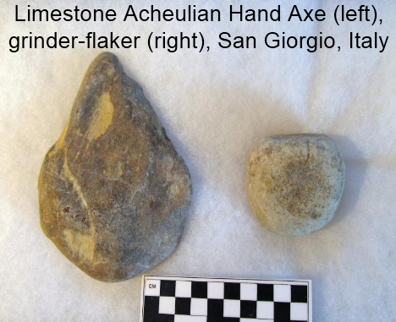

* **Surface collected, June 22, 2015, by Susan Murcott, San Giorgio, Italy, north of Monte Poggiolo, a prominent Acheulian site.**
* **Hand axe and abrader-flaker found in close proximity to each other.**
* **Hand axe shows signs of having been abraded and flaked.**
* **Abrader-flaker was used extensively based on use-wear analysis.**
* **The hand axe is not in a finished state and may have been in a hunter’s tool-kit as he watched game in the valley below before finishing his weapon.**

Acheulian Sites: 1 and 0.7 Mya

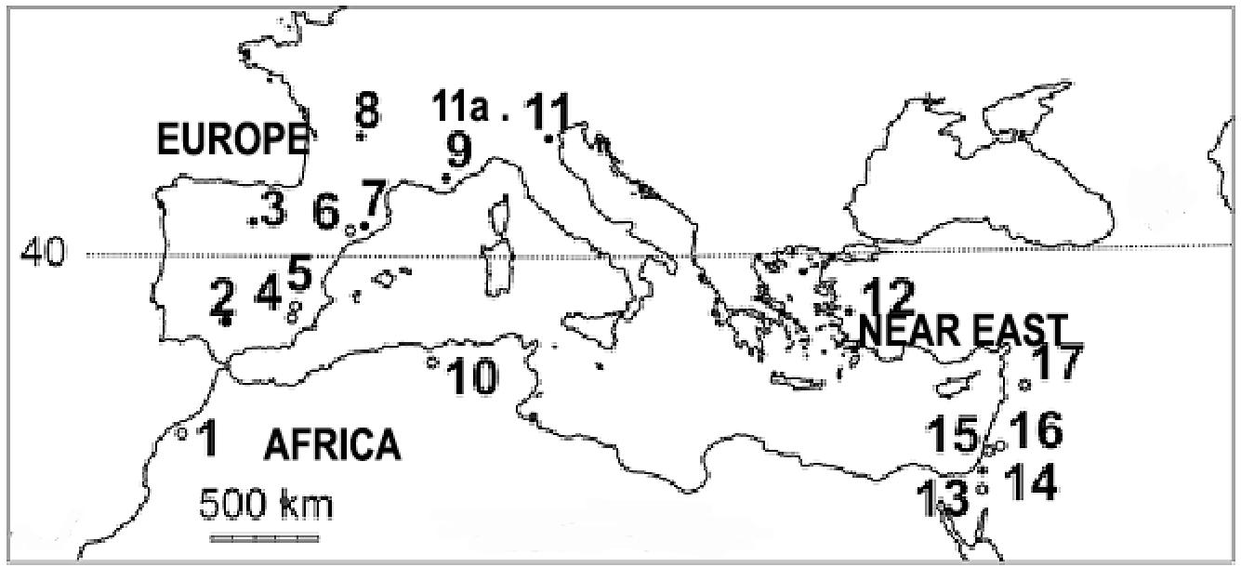

* **1, Thomas Quarry I, Morocco;**
* **2. Guadalquivir, Spain;**
* **3, Gran Dolina, Spain;**
* **4, Cueva Negra, Spain;**
* **5, Solana del Zamborino, Spain;**
* **6, Barranc de la Boella, Spain;**
* **7, Vallparadís, Spain;**
* **8, La Noira, France;**
* **9, Vallonet, France;**
* **10, Tighenif and Erraya, Algeria;**
* **11a San Giorgio, Italy**
* **11, Monte Poggiolo, Italy;**
* **12, Dursunlu, Turkey;**
* **13, Evron, Israel;**
* **14, Nahal Zihor, Israel;**
* **15, Bizat Rumana, Israel;**
* **16, Gesher Benot Yaaqov, Israel;**
* **17, Latame, Syria;**

